Exercise 1: Inventory Management System.

Why Data Structures & Algorithms Are Essential
- Enable fast data access and manipulation.
- Support real-time updates and dynamic data handling.
- Ensure consistency and avoid data duplication.
- Optimize resource usage and performance.

Suitable Data Structures for Inventory Management
- ArrayList - Suitable for small-scale inventory with minimal complexity.
- HashMap - Ideal for large inventories requiring fast lookup, insert, update, and delete.
- TreeMap - Useful when data needs to be maintained in a sorted order by keys.
Output
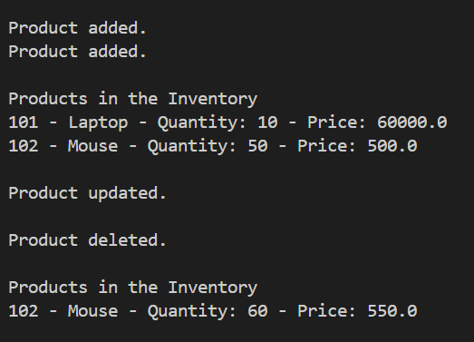
Time Complexity Using HashMap
- Add Product – O(1)
- Update Product – O(1)
- Delete Product – O(1)
- Search Product – O(1)

Optimization Tips:
- Use HashMap for fast access by productId.
- If you need sorted access, use TreeMap (but with O(log n) operations).
- Use indexing if storing in a database later for even better performance with SQL queries.

